MPL Pharmaceuticals Observations.

In this exercise we were analyzing the mouse drug trials of different chemotherapy drugs and their effect on tumor growth. The drugs tested included Capomulin, Ceftamin, Infubinol, Ketapril, Naftisol, Placebo, Propriva, Ramicane, Stelasyn, Zoniferol.

From the tests there are a few very important observations that need to be reported.

Of the drug set tested, the only ones that actually decreased the size of the tumor were Capomulin and Ramicane.

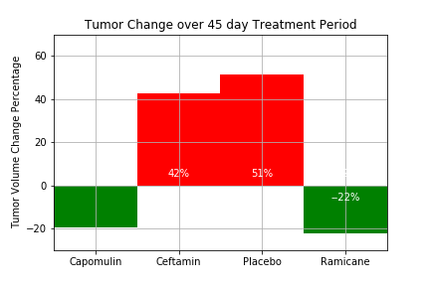
Ramicaine was 3% more effective than Capomulin and also faster acting than Capomulin.

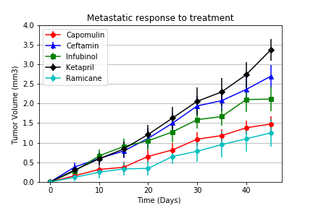

However, despite Ramicaine’s efficacy in shrinking the tumor size, it did not appear to be as safe as Capumulin in patient survivability.

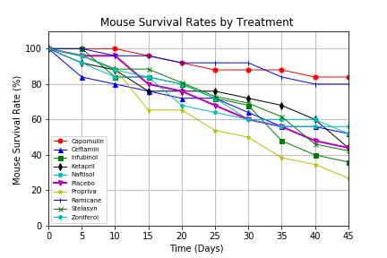

Overall, Capomulin may be the best option for survivability (>80%) and efficacy.
However, for a dire situation when a tumor needs to be shrunk quickly, Ramicaine may be your drug of choice.

Also, to note from these studies, is the danger of the drug Propriva. Survivability of this drug was less than 40%.



